Block QA

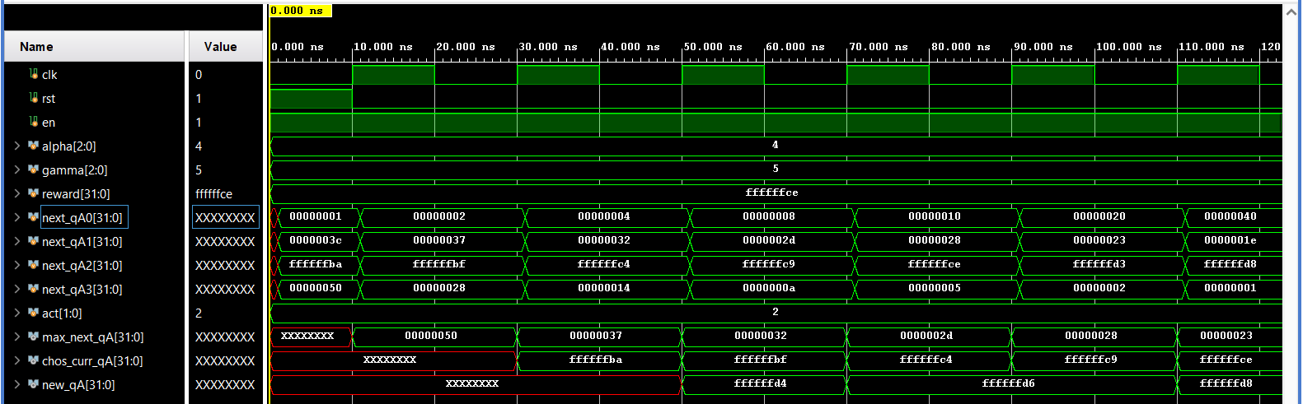

Block SD

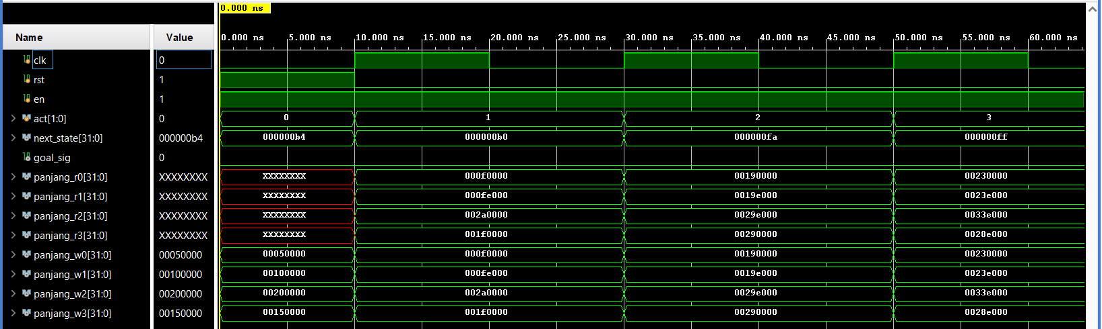

Block RD

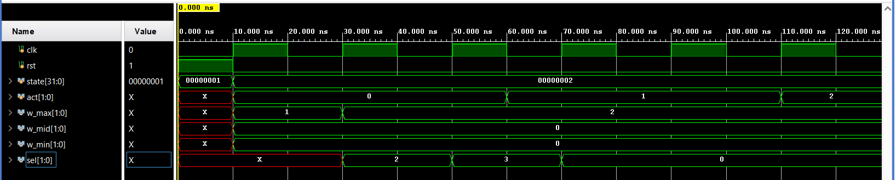

Block PG

